  Predictive Analytics for Customer Retention at Lloyds Banking Group  Exploratory Data Analysis and Predictive Modelling for Churn Reduction | Abstract  This project applies data science and machine learning techniques to analyse customer behaviour and predict churn at Lloyds Banking Group. It aims to provide actionable insights that help improve customer retention and support data-driven decision-making.  vyashimanshu774@gmail.com  Lloyds Banking Group Data Science & Analytics Virtual Experience Program (Forage)

Table Of Content:
Introduction
Objectives
Data Collection
Exploratory Data Analysis (EDA)
Business Recommendation
Data Preprocessing
Model Building
Model Evaluation
Conclusion
References

Chapter1. Introduction
- In today’s competitive banking industry, retaining customers has become as important as acquiring new ones. Customer churn, which refers to customers discontinuing their relationship with a bank, can significantly impact revenue and overall business performance. Therefore, identifying customers who are likely to churn and understanding the factors behind their decisions is crucial for developing effective retention strategies.
- This project, undertaken as part of the Lloyds Banking Group Data Science & Analytics Virtual Experience Program (Forage), focuses on applying data science techniques to analyse and predict customer churn. By performing exploratory data analysis (EDA), the project aims to uncover patterns, trends, and key variables that influence customer behaviour. Further, data preprocessing steps are applied to ensure data quality and consistency for accurate analysis.
- The project also involves building and evaluating machine learning models to predict the likelihood of customer churn. The insights generated from this analysis can help the organization take proactive measures, improve customer satisfaction, and enhance long-term business growth through data driven decision-making.

Chapter 2. Objective:
The key Objectives are:
- To perform exploratory data analysis (EDA) and understand customer behaviour patterns
- To identify the key factors influencing customer churn
- To clean and preprocess the dataset for accurate analysis
- To build and compare machine learning models for churn prediction
- To evaluate model performance using appropriate metrics such as accuracy, precision, recall, and F1-score
- To provide actionable insights that help improve customer retention strategies
Insights
Evaluation
Model Building
Data Pre-processing
Exploratory Data Analysis (EDA)
E

Data Collection

Chapter 3. Data Collection
The dataset used in this project was obtained from the Lloyds Banking Group Data Science & Analytics Virtual Experience Program (Forage). The data was provided in the form of an Excel file containing multiple worksheets (3–5 workbooks), each representing different aspects of customer information.
Customer Demographic
Customer_id | Age | Gender | Maritial_Status | IncomeLevel

Truncation Data
Customer_id | TransactionID | TransactionDate | AmountSpent | ProductCategory

Customer Service
Customer_id | InteractionID | InteractuinDate | InteractionType | ResolutionStatus

Online Activity
Customer_ID | LastLoginDate | LoginFrequency | ServiceUsage

Churn Status
Customer_id | Churn_status

Chapter 4. Exploratory Data Analysis
Exploratory Data Analysis (EDA) was conducted to understand the structure and characteristics of the dataset before modelling. This involved analysing data distributions, identifying missing values, and examining relationships between key variables such as customer behaviour, service usage, and churn. Various visualizations were used to uncover patterns and trends, which helped in feature selection and improving the overall quality of the data for building an effective predictive model.
1.Customer Demographic:
CustomerID | Age | Gender | Marital Status | Income Level
1 | 62 | M | Single | Low
2 | 65 | M | Married | Low
3 | 18 | M | Single | Low
4 | 21 | M | Widowed | Low
5 | 21 | M | Divorced | Medium
Data Understanding: Customer Demographics
- Shape of the dataset: (1000, 5)
- Duplicate rows: 0
- Total Missing values in the dataset: 0
Data columns (total 5 columns):
# Column Non-Null Count Ditype
0 CustomerID 1000 non-null int64
1 Age 1000 non-null int64
2 Gender 1000 non-null object
3 Marital Status 1000 non-null object
4 Income Level 1000 non-null object
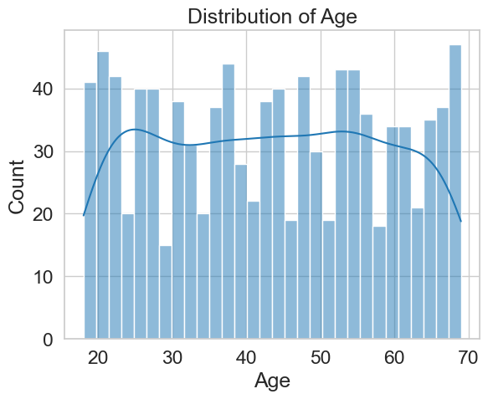
For Checking that Age is Normally Distributed Or not:
- skewness of Age: 0.013168103545372956
- kurtosis of Age: -1.2129695174429682
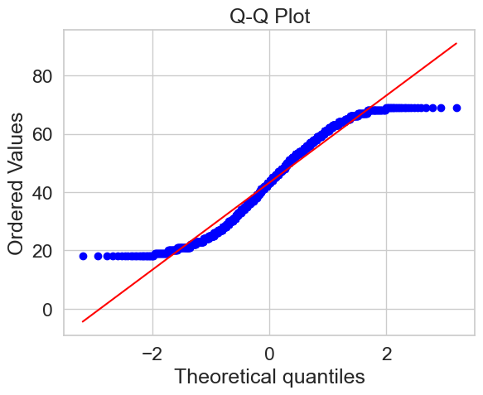

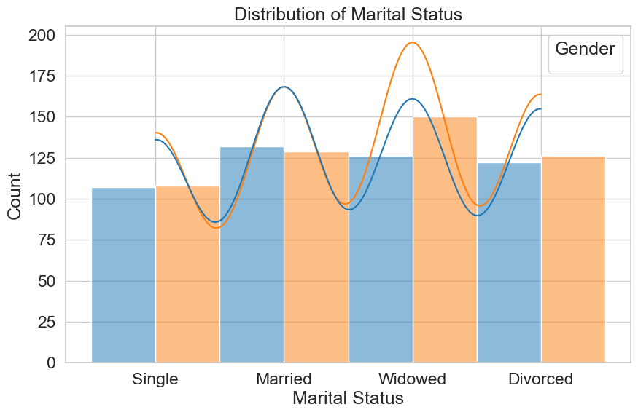
- Widowed category has the highest count, especially among females, indicating a noticeable concentration in this segment.
- Married customers are also a significant group, with both genders showing similar distribution, suggesting a stable customer base.
- Single customers have comparatively lower counts, which may indicate lower representation or engagement in the dataset.

2.Transanction History
CustomerID | Transaction_ID | Transaction Date | Amount Spent | Product Category
1 | 7194 | 2022-03-27 | 416.50 | Electronics
2 | 7250 | 2022-08-08 | 54.96 | Clothing
2 | 9660 | 2022-07-25 | 197.50 | Electronics
2 | 2998 | 2022-01-25 | 101.31 | Furniture
2 | 1228 | 2022-07-24 | 397.37 | Clothing
Data understanding: Transaction History
- Shape of the dataset: (5054, 5)
- Duplicate rows: 0
- Total Missing values in the dataset: 0
Data columns (total 5 columns):
- # Column Non-Null Count Ditype
- 0 CustomerID 5054 non-null int64
- 1 TransactionID 5054 non-null int64
- 2 transaction Date 5054 non-null datetime64[ns]
- 3 Amount Spent 5054 non-null float64
- 4 Product Category 5054 non-null object
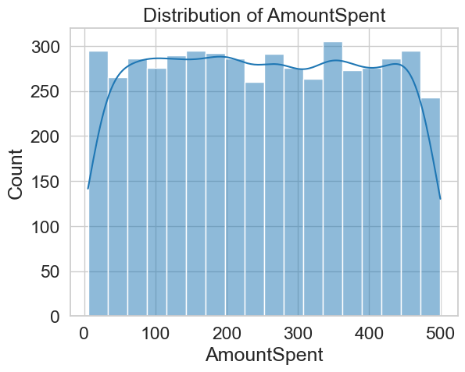
To Check How Data is Distributed:
- Skewness of Transaction Amount: 0.012092577177959096
- Kurtosis of Transaction Amount: -1.2020258458539834
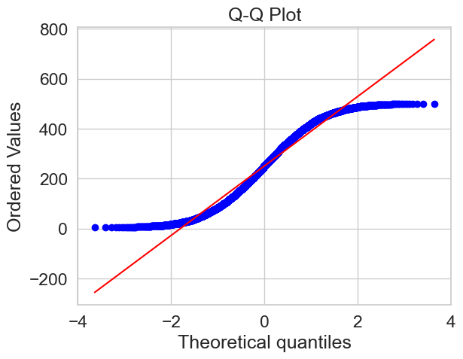

Distribution Of Product Category:
1.Product and its Count:
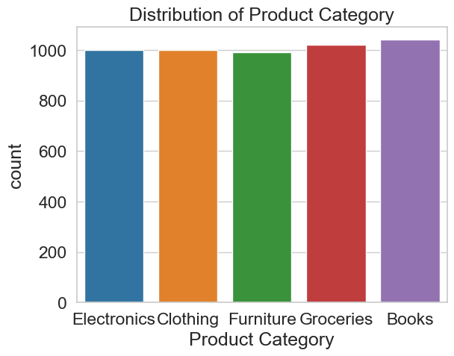
- All product categories have nearly equal distribution, indicating a well-balanced dataset with no major category dominance.
- Books and Groceries show slightly higher counts, suggesting marginally higher customer engagement or transactions in these categories.
- Furniture has the lowest count among all categories, which may indicate comparatively lower demand or interaction.
2.Product and its Sales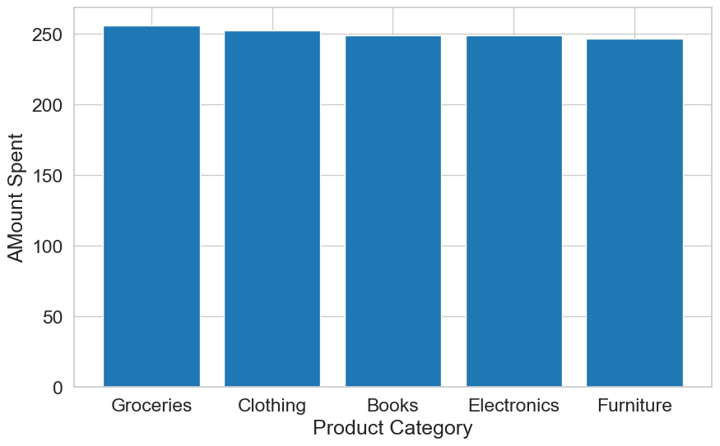
- Spending across all product categories is almost uniform, indicating consistent customer purchasing behaviours across categories.
- Groceries show the highest average spending, suggesting they are a frequent or essential purchase category.
- Furniture has the lowest spending among categories, which may indicate less frequent purchases or lower customer interest.
Monthly Sales:
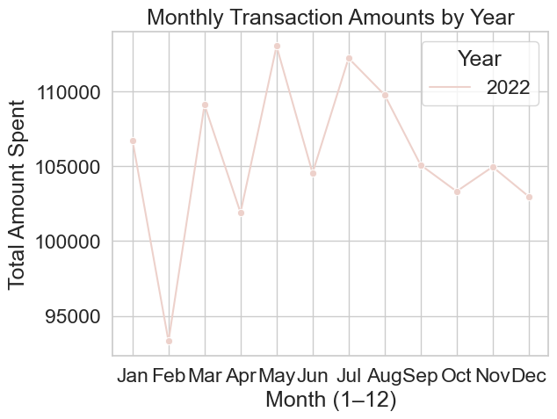
- Transaction amounts fluctuate throughout the year, with peaks observed around May and July, indicating higher customer spending during these months.
- A significant drop is seen in February, suggesting a seasonal decline or lower customer activity during that period.
Month Sales Vs Product
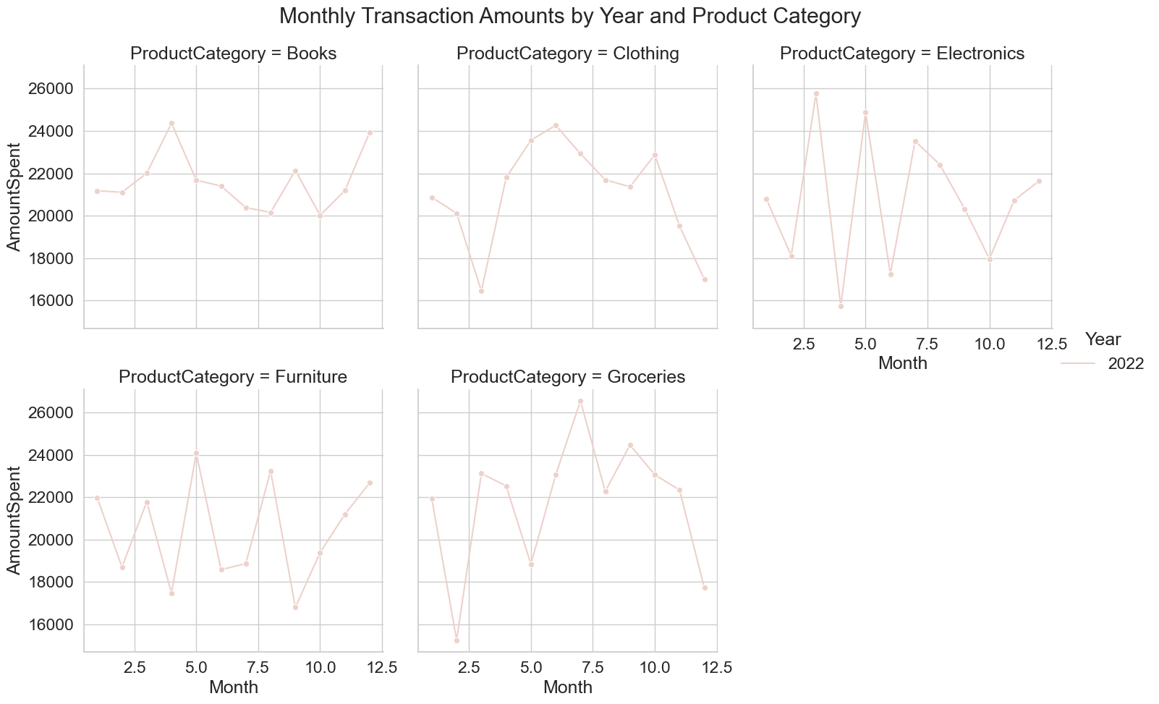
- Electronics shows the highest volatility with sharp spikes and drops
Unlike other categories, Electronics swings dramatically month-to-month (e.g., a deep dip around month 4 followed immediately by a peak in month 5). This suggests demand is likely driven by event-based purchases (e.g., launches, promotions), not steady consumption.
- Groceries peak mid-year and then steadily decline toward year-end
Spending rises strongly up to around month 7 (highest point across all categories), then gradually falls off through months 8–12. This indicates a seasonal consumption surge mid-year, possibly tied to lifestyle or pricing cycles, rather than consistent growth.
- Clothing shows a clear late-year drop despite mid-year strength
Clothing climbs from a low early in the year to a peak around months 5–6, but then trends downward sharply, ending near one of its lowest points. This pattern suggests front-loaded demand (spring/summer buying) with weaker late-year performance—unlike categories like Books or Furniture that recover later.

3.Customer Service
InteractionID | Interaction Date | Interaction Type | Resolution Status
6363 | 2022-03-31 | Inquiry | Resolved
3329 | 2022-03-17 | Inquiry | Resolved
9976 | 2022-08-24 | Inquiry | Resolved
7354 | 2022-11-18 | Inquiry | Resolved
5393 | 2022-07-03 | Inquiry | Unresolved
Customer Service Data Understanding:
- Shape of the dataset: (1002, 5)
- Duplicate rows: 0
- Total Missing values in the dataset: 0
Data columns (total 5 columns):
- # Column Non-Null Count Ditype
- 0 CustomerID 1002 non-null int64
- 1 InteractionID 1002 non-null int64
- 2 Interaction Date 1002 non-null datetime64[ns]
- 3 Interaction Type 1002 non-null object
- 4 Resolution Status 1002 non-null object

Distribution Of Interaction Type

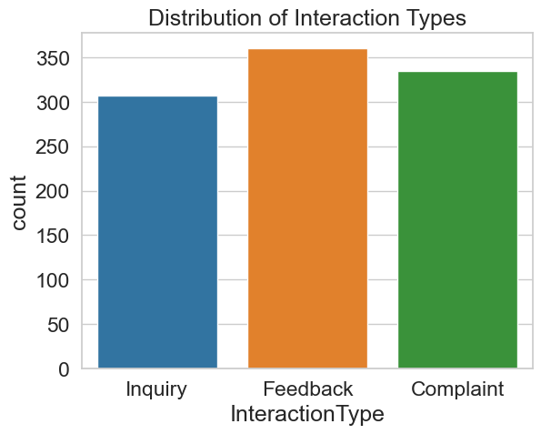
- Feedback slightly dominates but not overwhelmingly
Feedback has the highest count (~360), but it’s only about 7–8% higher than Complaints and ~15% higher than Inquiries. This indicates engagement is balanced rather than heavily skewed toward one interaction type.
- Complaints are unusually high relative to inquiries
Complaints (~335) exceed Inquiries (~305) by a noticeable margin. In many systems, inquiries typically lead—so this reversal suggests a potential service or product friction point driving more negative interactions.
- Total interaction mixes lean toward reactive rather than proactive engagement
Combining Feedback and Complaints (~695) vs Inquiries (~305) shows over 2× more user-initiated reactions than questions, implying users are more often responding to experiences than seeking information upfront.

Distribution Of Resolution Status
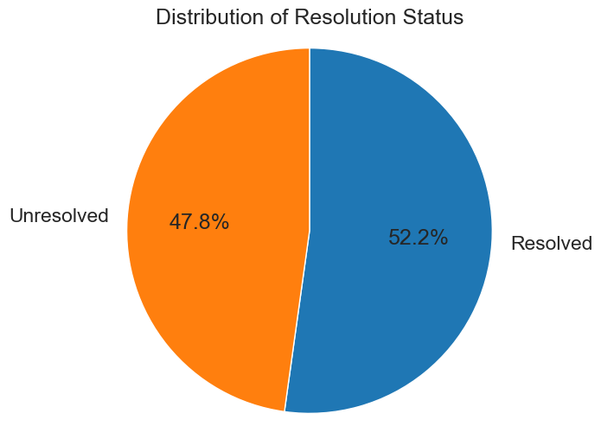
- Resolution rate is only marginally positive
With ~52% resolved vs ~48% unresolved, the system is barely keeping up—this narrow gap suggests operational strain, where small increases in volume could quickly push unresolved cases higher.
- High unresolved share signals backlog risk
Nearly half of all cases remain unresolved, indicating a potential accumulation issue, where tickets may be aging or not being closed efficiently, impacting overall service quality.

Distribution Of Resolution Status + Interaction Type
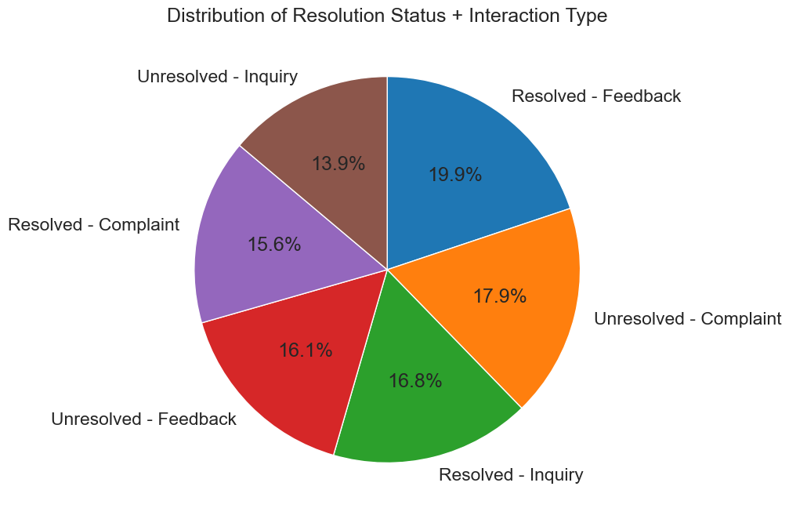
- Complaints have the worst resolution balance
Unresolved complaints (~17.9%) exceed resolved complaints (~15.6%), making complaints the only category where unresolved cases dominate, signalling a clear pain point in issue handling.
- Feedback is handled most effectively
Resolved feedback (~19.9%) is the largest single segment and significantly higher than unresolved feedback (~16.1%), indicating strong efficiency in closing feedback-related cases.
- Inquiries are relatively well-managed but not optimized
Resolved inquiries (~16.8%) are higher than unresolved (~13.9%), but the gap is modest—suggesting room to improve response speed or clarity to further reduce unresolved inquiries.
- Unresolved workload is driven mainly by complaints and feedback
Combined unresolved share for complaints + feedback (~34%) is much higher than inquiries (~13.9%), showing that complex or dissatisfaction-driven interactions are the main contributors to backlog, not simple questions.

4. Online Activity
CustomerID | Last Login Date | Login Frequency | Service Usage
1 | 2023-10-21 | 34 | Mobile App
2 | 2023-12-05 | 5 | Website
3 | 2023-11-15 | 3 | Website
4 | 2023-08-25 | 2 | Website
5 | 2023-10-27 | 41 | Website

data4 understanding: Online Activity
- Shape of the dataset: (1000, 4)
- Duplicate rows: 0
- Total Missing values in the dataset: 0
Data columns (total 4 columns):
- # Column Non-Null Count Ditype
- 0 CustomerID 1000 non-null int64
- 1 LastLoginDate 1000 non-null datetime64[ns]
- 2 Login Frequency 1000 non-null int64
- 3 Service Usage 1000 non-null object

How Data is Distributed
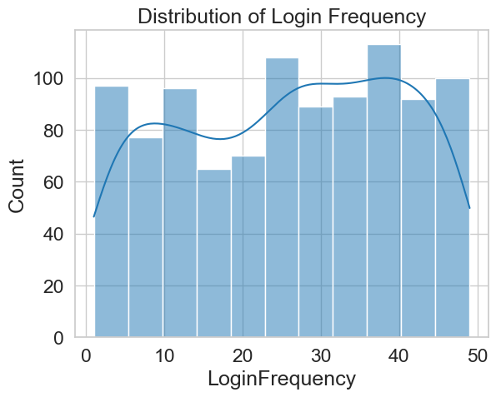
- Skewness of Online Activity: -0.12787740941651965
- Kurtosis of Online Activity: -1.1803380705125133

Login Frequency
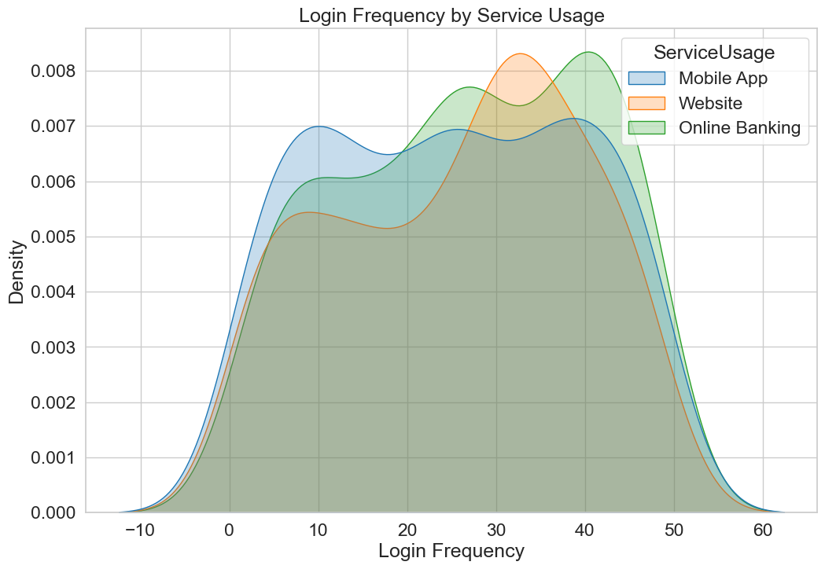
- Online Banking has the highest engagement ceiling
The green curve (Online Banking) extends further to the right and peaks around higher values (~40–45), indicating a larger group of very high-frequency users compared to Mobile App and Website.
- Website usage is more mid-frequency concentrated
The orange curve peaks sharply around ~30–35 and drops off faster on both sides, suggesting users tend to log in at moderate frequencies rather than very low or very high extremes.
- Mobile App shows the widest spread of user behaviours
The blue curve is flatter and more spread out, covering both low (~5–10) and high (~40+) login frequencies. This implies more diverse usage patterns, from casual to heavy users.
- Low-frequency users are similar across all channels
In the lower range (~0–10 logins), all three curves overlap closely, indicating user onboarding or occasional usage behaviour is consistent regardless of platform, with differences emerging only at higher engagement levels.

Distribution Of Service Usage
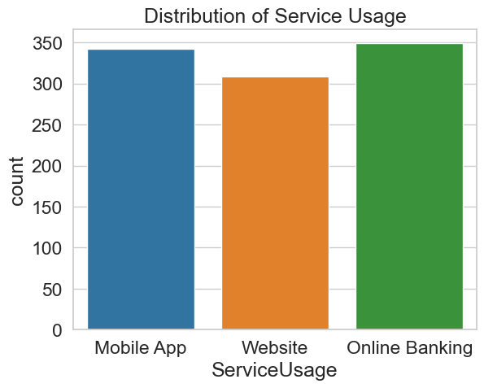

- Online Banking slightly leads overall usage
It has the highest count (~350), but only marginally above Mobile App (~340), indicating no dominant channel—users are evenly distributed.
- Website lags both digital channels
With the lowest count (~305), Website usage is clearly behind, suggesting a shift toward app-based and dedicated online banking platforms.
- Mobile App is nearly as strong as Online Banking
The small gap between Mobile App and Online Banking implies mobile adoption is already at parity with traditional online banking, highlighting strong user preference for mobile convenience.
Service Usage | Login Frequency
Mobile App | 8565
Online Banking | 9375
Website | 7972
Exploratory Data Analysis for Complete Data
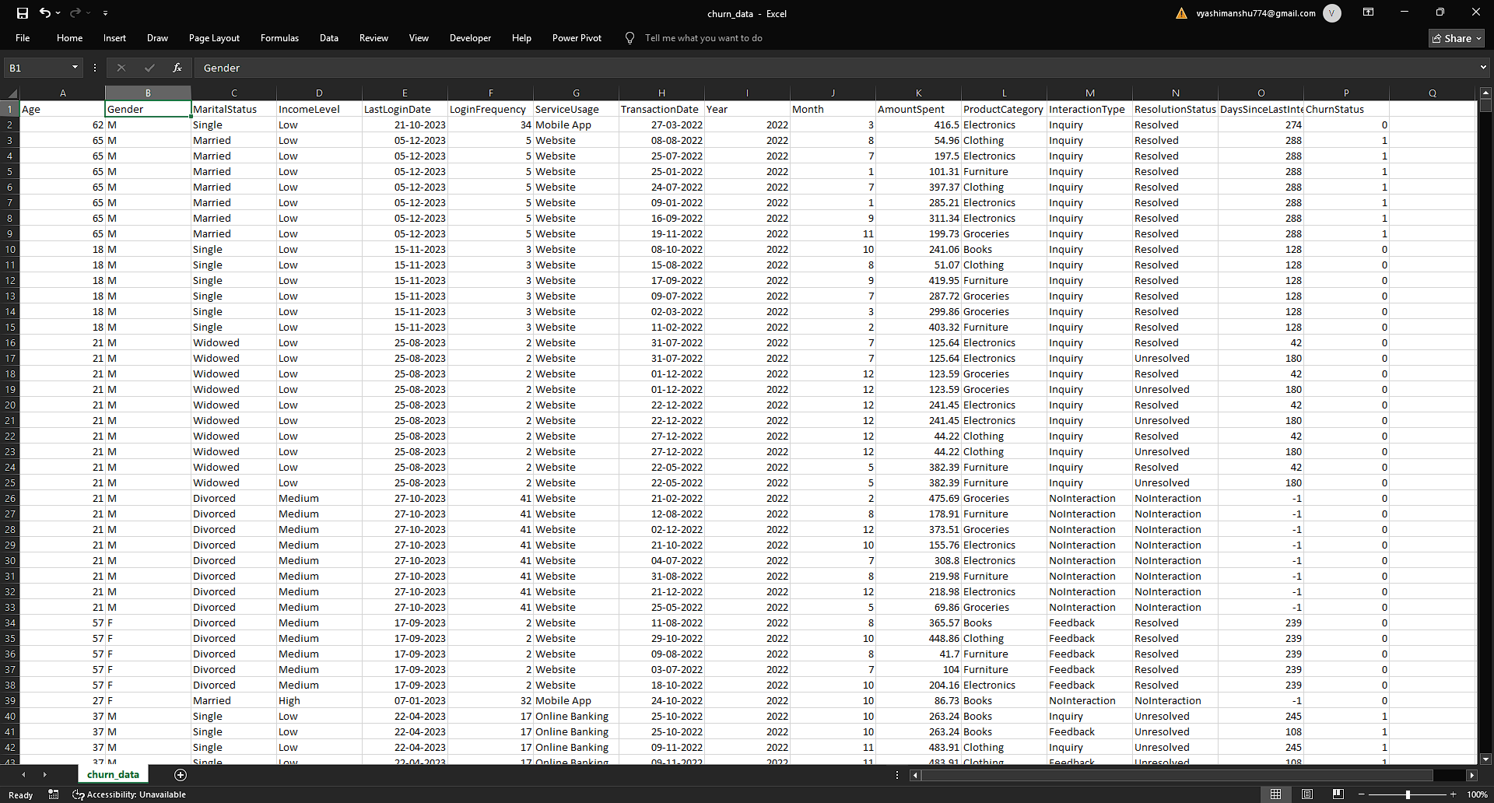
Data Understanding:
- Shape of the dataset: (6812, 19)
- Duplicate rows: 0
- Total Unique Customer: 1000
Missing Value:
- Interaction Type 1608
- Resolution Status 1608
- InteractionID 1608
- Interaction Date 1608
These columns have 1608 Null value, in which Interaction Id is not useful so we have dropped the column. For Resolution Status and Interaction Type, we replace with Unknown
To address missing values in the Interaction Date column, a derived feature DaysSinceLastInteraction was created. Instead of removing records or imputing arbitrary dates, the approach calculates the number of days between each interaction and the most recent date in the dataset. After adding new columns Interaction Date is removed, there is no use of this column
max_date = df['InteractionDate'].max()
df['DaysSinceLastInteraction'] = (max_date - df['InteractionDate']).dt. days.fillna(-1)
Age and Gender Churn Analysis:
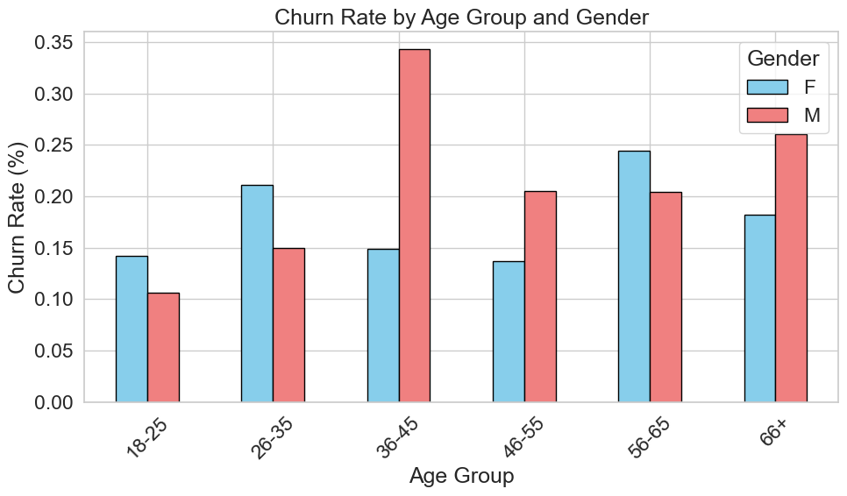
- Male churn spikes sharply in mid-age (36–45)
Male churn reaches its highest (~34%) in the 36–45 group—more than 2× higher than females in the same group (~15%), indicating a strong retention issue specifically for mid-career male customers.
- Female churn peaks later (56–65), not mid-age
Unlike males, female churn gradually rises and peaks around 56–65 (~24%), suggesting different lifecycle behaviour, where disengagement happens later for women.
- Young customers (18–25) are relatively stable across genders
Both male (~11%) and female (~14%) churn rates are lowest in this group, indicating strong early-stage retention, with churn risks increasing significantly as age progresses
Churn Rate by Gender.
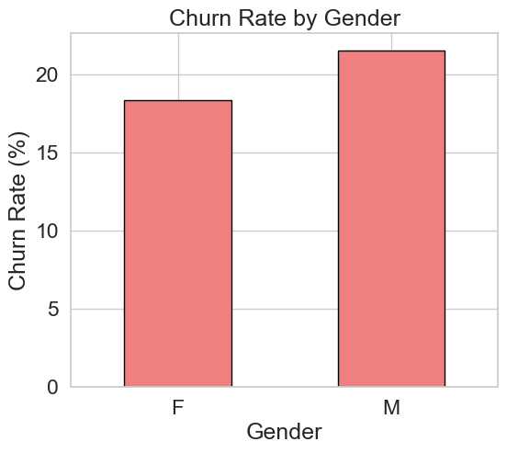
Marital Status, Income and Churn Analysis
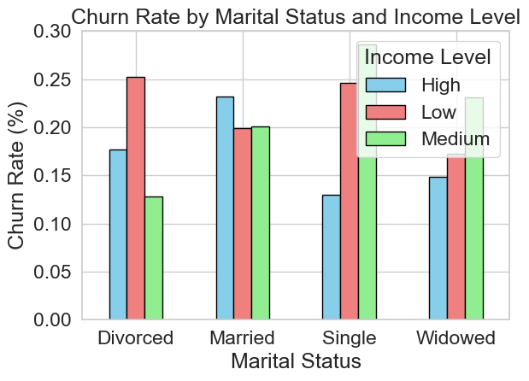
- Low-income individuals consistently show the highest churn across all marital statuses
For every group (Divorced, Married, Single, Widowed), low-income churn is the highest (~25% for Divorced and Single). This highlights income level as a stronger churn driver than marital status.
- Married customers are the most stable—especially at higher income levels
Married individuals with high income have the lowest churn (~23% but still lower relative within group comparisons), and the gap between income levels is smaller—indicating greater financial and behavioural stability.
- Single and divorced low-income groups are the highest-risk segments
Both groups show churn around ~25% for low income, significantly higher than their medium/high counterparts, suggesting these segments should be prioritized for retention strategies due to combined financial and social factors.

Churn Rate by Login Frequency
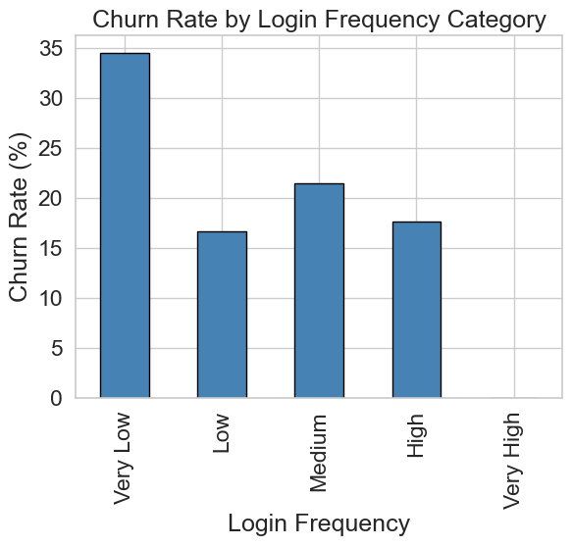
- Very low login frequency is the strongest churn signal
Users with Very Low login frequency have the highest churn (~34%), which is nearly double that of most other groups—making inactivity the clearest early warning sign.
- Churn drops significantly once users move beyond very low engagement
There is a sharp decline from Very Low (~34%) to Low (~17%), showing that even a small increase in engagement drastically improves retention.
- Higher engagement does not continuously reduce churn
After Low, churn fluctuates (Medium ~21%, High ~18%) instead of steadily decreasing, indicating that beyond a certain point, more logins do not strongly translate to lower churn—other factors likely drive retention.

Churn Rate by Service Usage
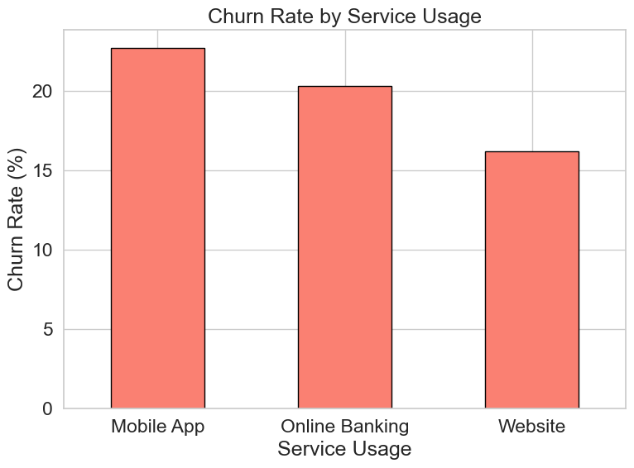
- Mobile App users have the highest churn (~23%)
This suggests that despite high adoption, the mobile experience may have usability issues, performance problems, or unmet expectations, leading to higher drop-off.
- Website users are the most retained (~16% churn)
The lowest churn on the Website indicates that users who prefer this channel are likely more stable or intentional users, possibly using it for specific, goal-driven tasks.
- Online Banking sits in the middle, indicating balanced experience
With churn around ~20%, it suggests moderate satisfaction—not as problematic as Mobile App, but not as stable as Website, highlighting room for improvement in engagement or features.

Churn Rate by Month
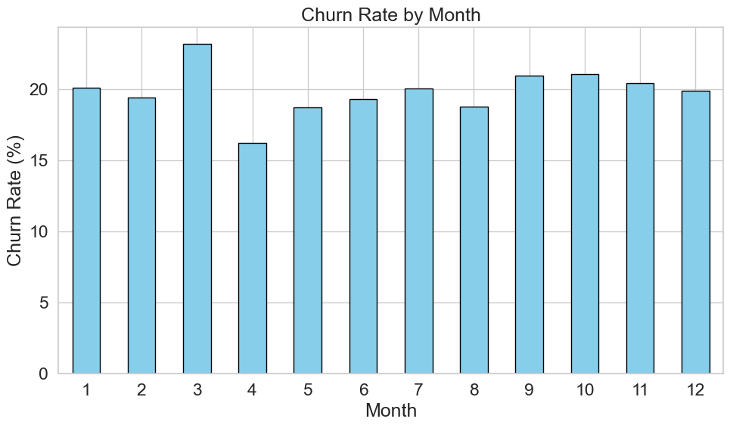
- March has the highest churn spike (~23%)
This stands out clearly compared to surrounding months, indicating a potential seasonal or event-driven trigger causing increased customer drop-off.
- April shows the lowest churn (~16%) right after the peak
The sharp drop from March to April suggests temporary factors (e.g., campaigns, billing cycles, or external events) rather than a sustained trend.
- Churn stabilizes in the second half of the year (~20–21%)
From July to December, churn remains relatively consistent, indicating a steady-state behaviour where no major seasonal disruptions occur.

Amount Spent by Product and Churn Rate

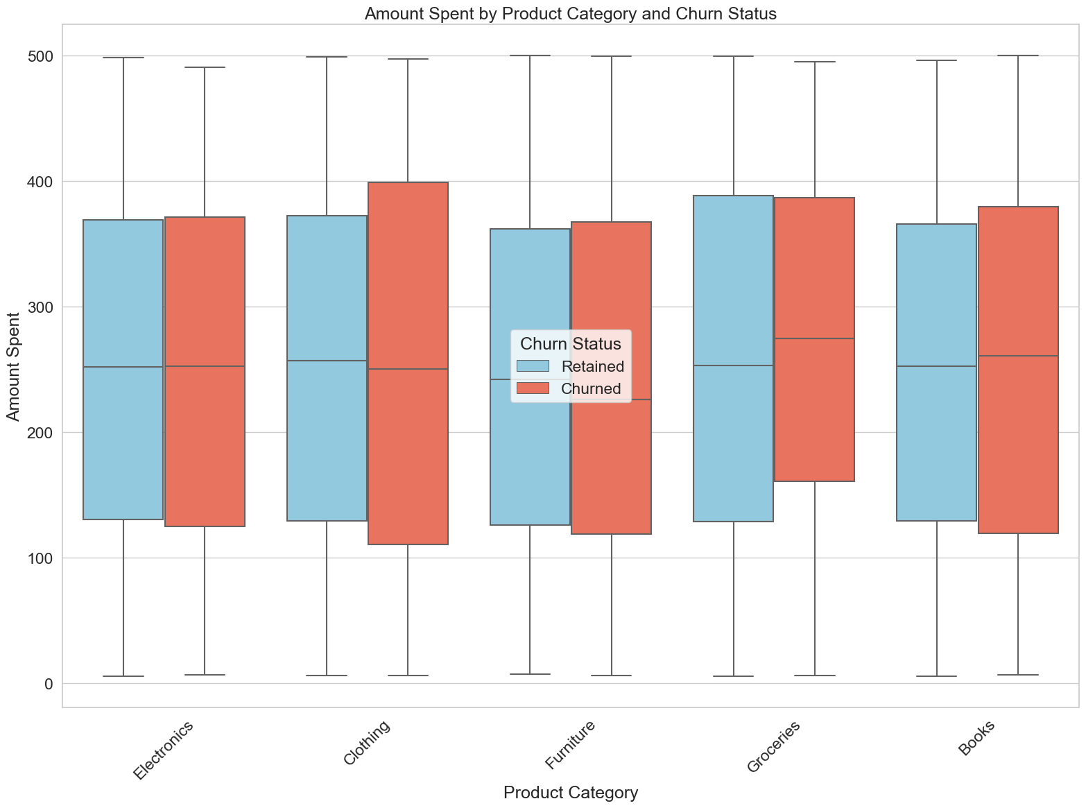
- Churned users often spend as much—or more—than retained users
Across categories like Groceries and Books, the median spending of churned customers is slightly higher. This indicates high-value customers are also leaving, which is a critical business risk.
- Spending distributions are very similar between churned and retained groups
The heavy overlap in boxplots across all categories suggests that spending alone is not a strong predictor of churn—other factors (engagement, service issues) are likely driving it.
- Groceries have the highest spending concentration for churned users
Churned users in Groceries show higher median and upper ranges, indicating frequent, high spenders are still churning, possibly due to pricing sensitivity or competition.
- No category shows strong retention advantage based on spending
In categories like Electronics, Clothing, and Furniture, retained users do not consistently outspend churned ones, reinforcing that loyalty is not tied directly to higher spending behaviour.

Churn Rate by Interaction Type and Resolution Status

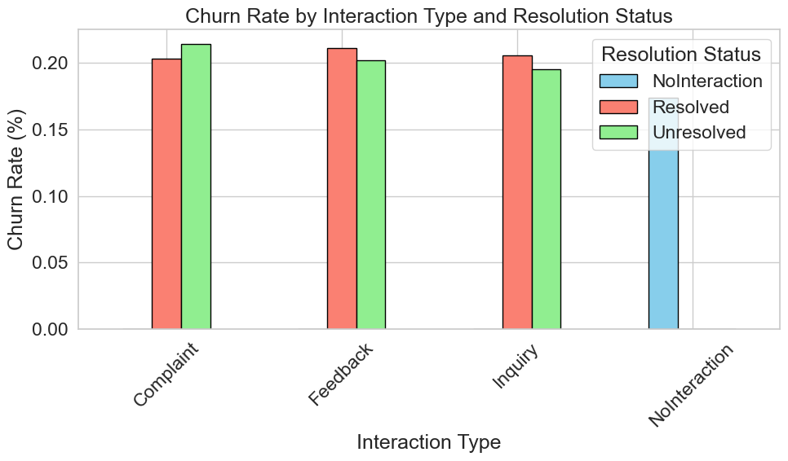
- Unresolved complaints drive the highest churn (~21–22%)
Among all combinations, complaints that remain unresolved have the highest churn, confirming that poor issue resolution directly leads to customer loss.
- Resolution reduces churn—but not drastically
For all interaction types (Complaint, Feedback, Inquiry), resolved cases still show ~20% churn, only slightly lower than unresolved. This suggests resolution quality or timeliness may be insufficient, not just resolution itself.
- Feedback-related churn is consistently high regardless of resolution
Both resolved (~21%) and unresolved (~20%) feedback cases show similar churn, indicating feedback interactions may reflect deeper dissatisfaction or disengagement signals.
- Customers with no interaction still churn at a notable rate (~17%)
Even without any interaction, churn is significant, implying silent churn risk—customers may leave without raising issues, highlighting the need for proactive engagement.

Churn Rate by Last Interaction
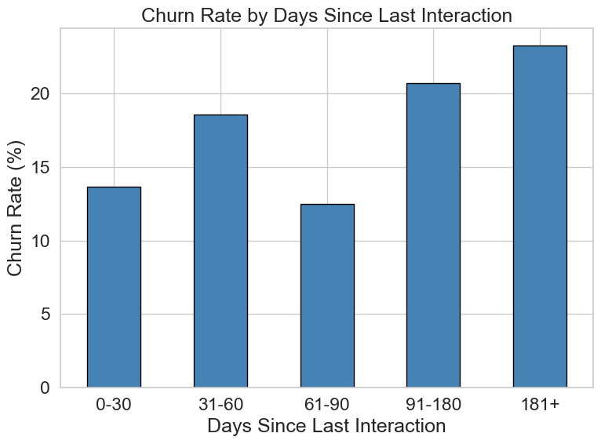
- Churn increases significantly with inactivity duration
Customers inactive for 181+ days have the highest churn (~23%), compared to ~13–14% for 0–30 days. This shows a strong positive relationship between inactivity and churn risk.
- Critical risk threshold begins after ~90 days
There is a noticeable jump from ~12% (61–90 days) to ~21% (91–180 days), indicating that customers inactive beyond 3 months enter a high-risk churn zone.
- Recent interactions strongly improve retention
Customers with activity in the last 30 days have relatively low churn (~13%), confirming that frequent engagement is a key driver of customer retention.

Chapter 5. Business Recommendation
1. Deploy a 90-day inactivity trigger with automated re-engagement
- Build a real-time alert system that flags any customer approaching 90 days of inactivity. At 60 days, send a personalised value reminder (product summary, exclusive offer). At 90 days, assign a relationship manager for high-value accounts and trigger an automated SMS/email win-back sequence for mass market. Even recovering 10% of high-risk inactive would have material impact given the ~34% churn rate at very low login frequency.
2. Fix complaint resolution — move from 52% to 75%+ resolution rate
- Unresolved complaints are the only interaction category where unresolved cases exceed resolved ones. Lloyds should introduce tiered SLAs (e.g. complaints resolved within 48h), assign dedicated complaint resolution agents, and implement a real-time escalation protocol for cases aging beyond 72 hours. Closing this gap directly reduces churn among the highest-dissatisfaction segment.
3. Launch a targeted retention campaign for 36–45 male customers
- This cohort churns at more than 2× the rate of comparable female customers. Investigate whether this maps to career transitions, mortgage completions, or life stage events. Design a dedicated product bundle (investment accounts, protection products, financial planning) specifically promoted to this segment. Similarly, design separate 56–65 female-focused offerings (retirement planning, savings products) where female churn peaks.
4. Conduct a mobile app UX audit and address friction points
- Mobile App churn (~23%) is 7 percentage points above Website (~16%) despite similar usage volumes. Commission a UX audit to identify specific drop-off points — login friction, feature discoverability, performance on older devices, and notification fatigue. Given mobile is the fastest-growing channel, unchecked churn here will compound significantly over 12–24 months.
5. Investigate the March churn spike and build a pre-emptive intervention
- The sharp March peak (~23%) followed by April recovery (~16%) indicates a cyclical event — likely annual fee notices, mortgage rate renewals, or competitor switching offers in Q1. Run a causal analysis against internal billing and contract data. Pre-empt the spike with a February loyalty outreach campaign offering rate reviews, cashback incentives, or proactive fee waivers for at-risk customers.

6. Develop income-differentiated retention products for low-income segments
- Low-income single and divorced customers churn at ~25% — the highest segment. Create a "value banking" tier with fee waivers, overdraft forgiveness, or micro-savings nudges to increase perceived value. These customers may be churning due to cost sensitivity rather than service dissatisfaction. Financial inclusion products can simultaneously reduce churn and strengthen Lloyds' regulatory and ESG positioning.
7. Implement XGBoost model scores into CRM for proactive scoring
- With 98.5% test accuracy and a 0.014 train-test gap confirming minimal overfitting, the XGBoost model is production-ready. Integrate it into the CRM to generate weekly churn probability scores per customer. Use scores to prioritise outreach, personalise offers, and measure the lift of each retention intervention — closing the feedback loop between model and business action.

The first two recommendations are the most urgent because they address churn that is already happening and already measurable — inactivity and unresolved complaints are not forecasts, they are live problems costing Lloyd’s money today.
Recommendations 3 through 6 target specific segments and channels where churn is concentrated. Their importance lies in precision — a generic retention campaign would dilute spend across all customers, whereas these four interventions go exactly where the data says the problem is worst.



Chapter 6. Data Pre-processing
- To ensure a systematic and reproducible workflow, a pipeline-based preprocessing approach was used. This helps automate data transformations and avoids data leakage during model training.
- A pipeline was constructed using components from the scikit-learn library
Pipeline Components:
The preprocessing pipeline includes:
- Column Transformer
  - Separates numerical and categorical features
  - Applies appropriate transformations to each type
- Transformations Applied
  - Encoding of categorical variables
  - (Optional) Scaling of numerical variables
Advantages of Using Pipeline
- Ensures consistency in preprocessing
- Reduces manual errors
- Makes the workflow reusable and clean
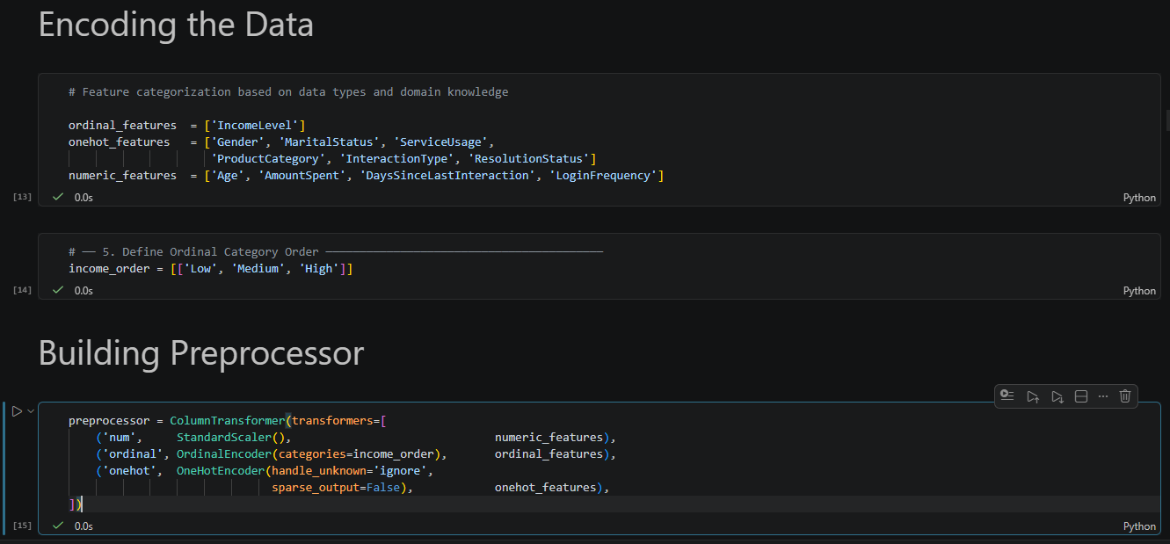

Encoding Techniques:
- Ordinal Encoding
- One Hot Encoding
Ordinal Encoding
Ordinal encoding was used for features with a natural order.
Example:
- Income Level:
  - Low → 0
  - Medium → 1
  - High → 2
Implementation:
- Used Ordinal Encoder from scikit-learn
- Preserved the inherent ranking of categories
Why Used?
- Maintains meaningful order
- Suitable for features with ranking
One-Hot Encoding
One-hot encoding was applied to nominal categorical variables (no order).
Example Features:
- Gender
- Marital Status
- Product Category
- Service Usage
How It Works:
- Each category is converted into a separate binary column (0 or 1)
Implementation:
- Used OneHotEncoder from scikit-learn
- Handled unknown categories using:
Chapter 7. Model Selection
Model selection is a crucial step in the machine learning pipeline where different algorithms are evaluated to identify the best-performing model for the given dataset.
The goal is to choose a model that:
- Achieves high accuracy
- Generalizes well to unseen data
- Avoids overfitting and underfitting
importance of Model Selection
- Model selection is important for the following reasons:
Performance Optimization
- Different models perform differently depending on the dataset. Selecting the right model ensures optimal predictive performance.
Generalization Ability
- A good model should not only perform well on training data but also on test data.
Avoiding Overfitting and Underfitting
- Overfitting: Model learns noise
- Underfitting: Model fails to learn patterns
- Proper model selection balances both.
Computational Efficiency
- Some models are faster and more efficient than others, which is important for large datasets.
Interpretability
- Certain models are easier to interpret, which is useful in business decision-making.
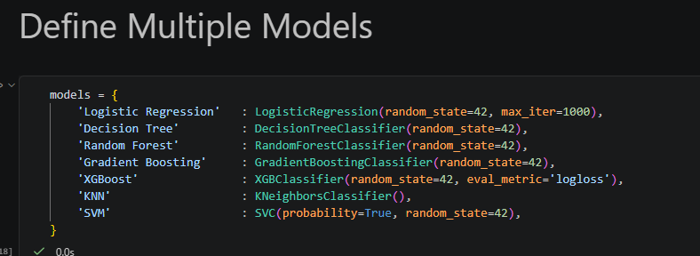
Model | Type | Strengths | Weaknesses
Logistic Regression | Linear | Simple, interpretable | Cannot handle complex patterns
Decision Tree | Non-linear | Easy to visualize | Overfitting
Random Forest | Ensemble | High accuracy, robust | Less interpretable
KNN | Instance | Simple, no training | Slow, sensitive to scaling
SVM | Margin | Works in high dimensions | Slow, complex tuning
Naive Bayes | Probabilistic | Fast, good for categorical | Strong assumptions
Model selection plays a vital role in building an effective machine learning system. Different models have different strengths and limitations, and no single model is best for all datasets.
In this project:
- Multiple models can be tested
- Performance can be compared using metrics like accuracy, precision, recall, and F1-score
- The best model is selected based on overall performance and generalization ability
Best Model Selected: XGBoost
- In this project, multiple machine learning models were evaluated for customer churn prediction. Among all the models tested, XGBoost (Extreme Gradient Boosting) achieved the best performance in terms of accuracy, robustness, and generalization.
What is XGBoost?
XGBoost is an advanced implementation of the gradient boosting technique. It builds models sequentially, where each new model corrects the errors of the previous ones.
It is widely used due to:
- High efficiency
- Scalability
- Superior predictive performance
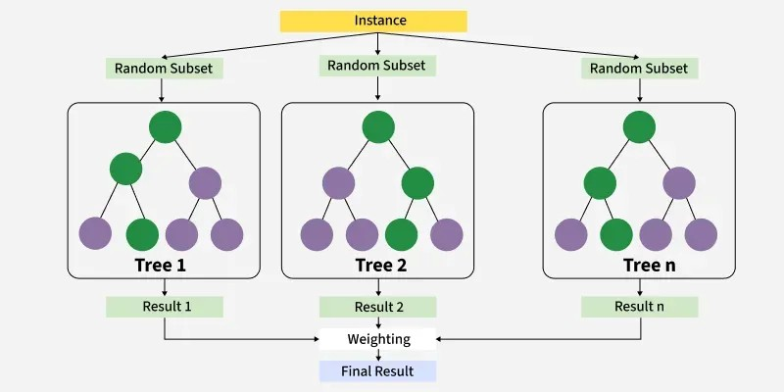
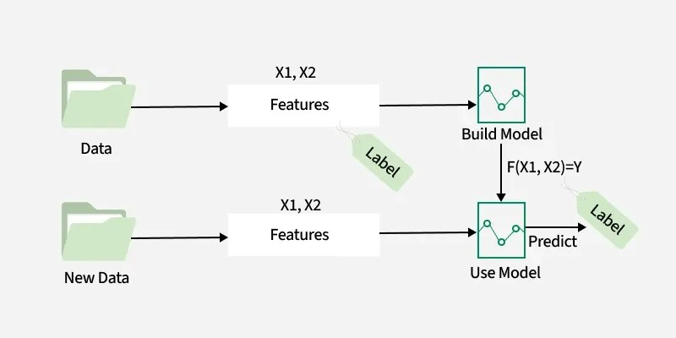
Why XGBoost Performed Best
The following factors contributed to XGBoost being the best model in this project:
1. Handling of Complex Patterns
- Captures both linear and non-linear relationships effectively
- Suitable for structured/tabular data like churn datasets
2. Built-in Regularization
- Includes L1 and L2 regularization
- Helps prevent overfitting
3. Handling Missing Values
- Automatically learns how to deal with missing data
- Reduces need for heavy preprocessing
4. Feature Importance
- Provides scores indicating which features are most important
- Helps in model interpretability
5. Ensemble Learning
- Combines multiple weak learners (decision trees)
- Produces a strong predictive mode
- 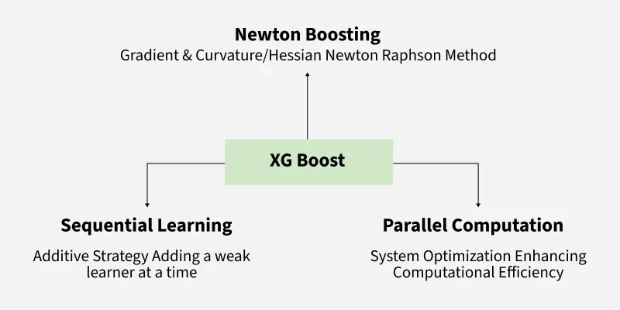

Chapter 8. Model Evaluation
- Model evaluation is the process of assessing how well a machine learning model performs on unseen data. It helps determine whether the model can generalize effectively beyond the training dataset.
- In this project, model evaluation was used to compare different models and select the best-performing one, which is XGBoost.
Importance of Model Evaluation
Model evaluation is important for the following reasons:
1. Measures Model Performance
- Helps determine how accurately the model predicts outcomes
2. Detects Overfitting and Underfitting
- Ensures the model is not memorizing or under-learning
3. Model Comparison
- Allows comparison of multiple models to select the best one
4. Improves Decision Making
- Provides insights into model reliability
5. Business Impact
- In churn prediction, better evaluation leads to better customer retention strategies

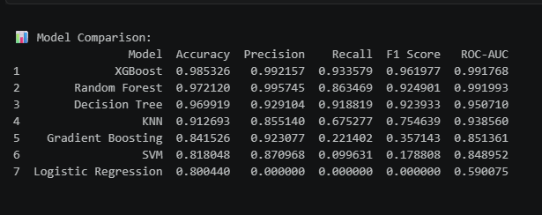
Metric | What it Measures | Focus Area | When to Use | Limitation
Accuracy | Overall correctness of model | Total predictions | When data is balanced | Misleading in imbalanced data
Precision | Correctness of positive predictions | False Positives (FP) | When FP is costly | Ignores false negatives
Recall | Ability to find all actual positives | False Negatives (FN) | When FN is costly | Ignores false positives
F1-Score | Balance between precision & recall | Both FP & FN | When dataset is imbalanced | Harder to interpret
Confusion Matrix | Detailed prediction breakdown | TP, TN, FP, FN | To understand errors | Not a single score
ROC-AUC | Model performance across thresholds | TPR vs FPR | For comparing models | Less intuitive
1. Accuracy
- Accuracy is the percentage of total correct predictions made by the model.
2. Precision
- Precision is the percentage of correct positive predictions out of all predicted positives.
3. Recall (Sensitivity)
- Recall is the percentage of actual positive cases correctly identified by the model.
4. F1-Score
- F1-score is the balance between precision and recall.
5. Confusion Matrix
- Confusion matrix is a table that shows correct and incorrect predictions (TP, TN, FP, FN).
6. ROC-AUC
- ROC-AUC measures how well the model can distinguish between classes
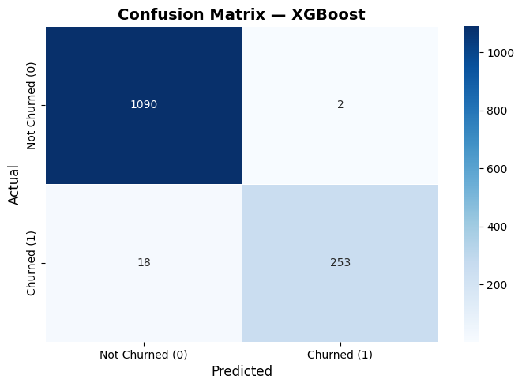
Feature Importance:
- Feature importance plays a crucial role in a churn prediction model by identifying which features have the most influence on customer churn. In models like XGBoost, feature importance helps highlight key factors such as usage patterns, customer demographics, or service history that drive churn behaviours. This not only improves model interpretability but also enables businesses to focus on the most impactful variables for decision-making. By understanding which features contribute most, companies can design targeted retention strategies, optimize resources, and enhance overall model performance by potentially removing less relevant features.
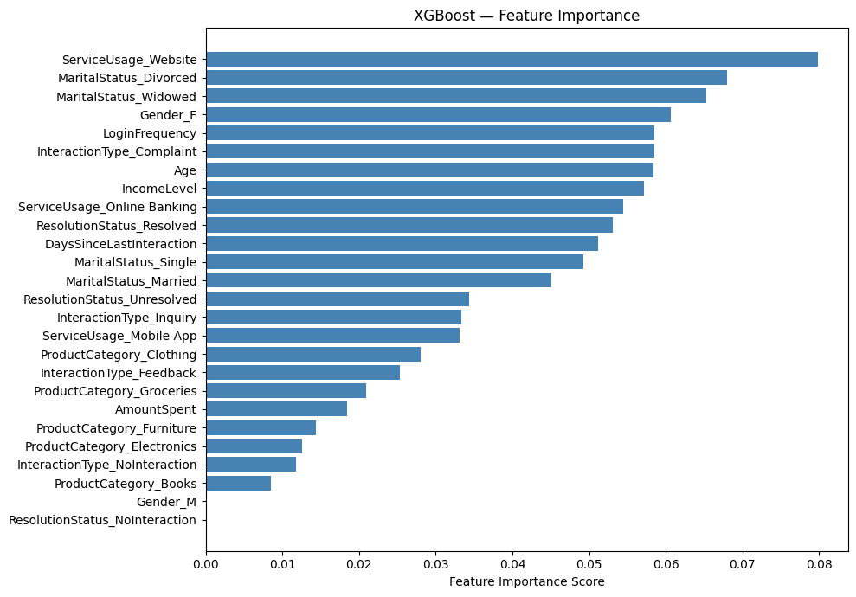
ROC – Curve:
- The ROC curve (Receiver Operating Characteristic curve) is important because it evaluates how well a classification model can distinguish between classes across different threshold values. It plots the true positive rate (recall) against the false positive rate, providing a comprehensive view of model performance rather than relying on a single metric like accuracy. In models such as XGBoost, the ROC curve helps in selecting the optimal threshold and comparing performance with other models. A higher Area Under the Curve (AUC) indicates better model performance, making it a reliable metric for assessing classification quality, especially in imbalanced datasets like churn prediction.
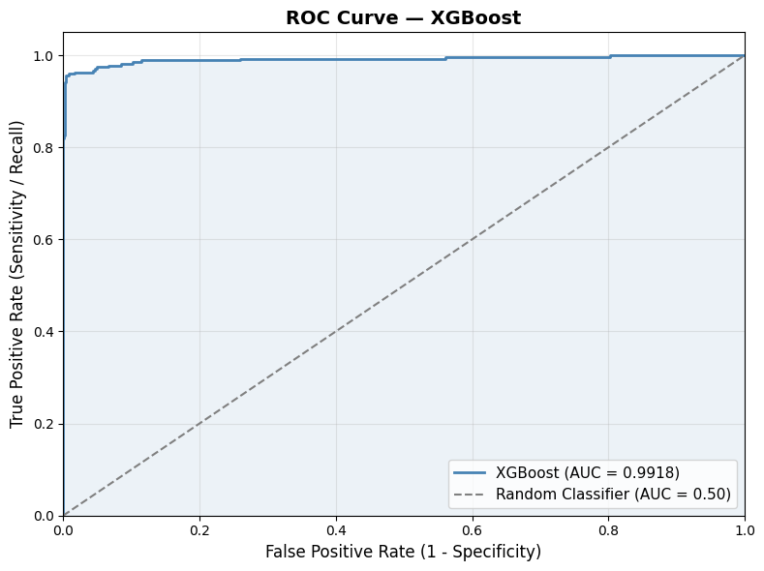

Under Fitting and Over Fitting
- Underfitting:
Underfitting occurs when a model is too simple to capture the underlying patterns in the data, resulting in poor performance on both training and testing datasets. It means the model has not learned enough from the data, often due to insufficient complexity, fewer features, or inadequate training. This leads to high bias and low accuracy, making the model unreliable for predictions.
- Overfitting:
Overfitting happens when a model learns the training data too well, including noise and irrelevant details, causing excellent performance on training data but poor results on unseen data. This indicates high variance, where the model fails to generalize. Models like XGBoost address this issue using regularization techniques.
- Role and Importance:
Understanding underfitting and overfitting is essential to build a balanced model that generalizes well. Avoiding underfitting ensures the model captures meaningful patterns, while preventing overfitting ensures it performs well on new data. Proper model selection, tuning, and validation techniques help achieve this balance, leading to more accurate and reliable predictions.
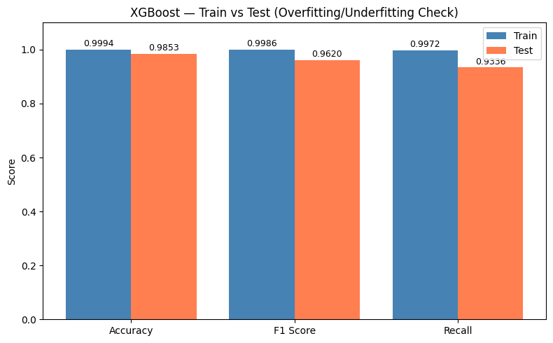
- ✅ GOOD FIT — Train (0.9994) ≈ Test (0.9853)
- Gap: 0.0141
- → Model is generalizing well!

Chapter 9. Conclusion
- This project successfully applies a full data science lifecycle — from multi-source data integration and EDA through preprocessing, model selection, and evaluation — to the practical business problem of customer churn at Lloyds Banking Group. The analysis reveals that churn is not primarily driven by spending behaviour or product usage, but by engagement signals: login inactivity, unresolved service issues, and specific demographic life-stage combinations.
- The XGBoost model delivers strong predictive performance (98.5% test accuracy, 99.9% training accuracy, train-test gap of 0.014) and is validated as generalisable with minimal overfitting. Feature importance analysis further confirms that engagement-related variables — login frequency, days since last interaction, and resolution status — are the dominant predictors, aligning with and reinforcing the EDA findings.
- The most actionable finding is the 90-day inactivity threshold: churn nearly doubles beyond this point, making it a clear, measurable trigger for intervention. Paired with a complaint resolution overhaul, a mobile UX improvement programme, and CRM-integrated model scoring, Lloyds has a data-backed framework to meaningfully reduce churn, retain high-value customers, and improve long-term revenue performance.

Chapter 10. References
- Forage / Lloyds Banking Group Platform
- Data Science & Analytics Virtual Experience Program
- Forage, 2023. Customer dataset (demographics, transactions, service interactions, online activity, churn status).
- https://www.theforage.com/simulations/lloyds-banking-group/data-science-analytics-3vlv
- Chen, T. & Guestrin, C. Conference Paper
- XGBoost: A scalable tree boosting system
- Proceedings of the 22nd ACM SIGKDD International Conference on Knowledge Discovery and Data Mining, 2016, pp. 785–794.
- https://dl.acm.org/doi/10.1145/2939672.2939785

